**Ch2-WPC-AllTables**

**Homework:** Chapter 2 WPC All Tables - Due ___ ___ __ Before Class

* This is a simplified version of the Access Workbench Exercise in the textbook. Follow along in the textbook for more detailed descriptions and pictures, but only the columns and data shown in this assignment are needed.
* The EMPLOYEE table was created in Chapter 1. This assignment creates the DEPARTMENT, PROJECT, and ASSIGNMENT tables.

In the “Access Workbench Exercises” in Chapter 1, we created a database for the Wedgewood Pacific Corporation (WPC) of Seattle, Washington, and created and populated the EMPLOYEE table. In this exercise, we will build the rest of the tables needed for the database, create the referential integrity constraints between them, and populate them.

The full set of normalized tables for the WPC database is as follows:

* DEPARTMENT (DepartmentName, BudgetCode, OfficeNumber, Phone)
* EMPLOYEE (EmployeeNumber, FirstName, LastName, *Department*, Phone, Email)
* PROJECT (ProjectID, ProjectName, *Department*, MaxHours, StartDate, EndDate)
* ASSIGNMENT (*ProjectID*, *EmployeeNumber*, HoursWorked)

The primary key of DEPARTMENT is DepartmentName, the primary key of EMPLOYEE is EmployeeNumber, and the primary key of PROJECT is ProjectID. Note that the EMPLOYEE table is the same as the table we have created, except that Department is now a foreign key. In EMPLOYEE and PROJECT, Department is a foreign key that references DepartmentName in DEPARTMENT. Note that a foreign key does not need to have the same name as the primary key to which it refers. The primary key of ASSIGNMENT is the composite (ProjectID, EmployeeNumber). ProjectID is also a foreign key that references ProjectID in PROJECT, and EmployeeNumber is a foreign key that references EmployeeNumber in EMPLOYEE.

The referential integrity constraints are:

* Department in EMPLOYEE must exist in DepartmentName in  DEPARTMENT
* Department in PROJECT must exist in DepartmentName in DEPARTMENT
* ProjectID in ASSIGNMENT must exist in ProjectID in PROJECT
* EmployeeNumber in ASSIGNMENT must exist in EmployeeNumber in EMPLOYEE

**Column Characteristics for the DEPARTMENT Table**

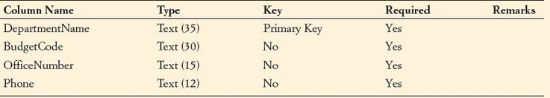

1. The above figure shows the column characteristics for the WPC DEPARTMENT table. Using the column characteristics, create the DEPARTMENT table in the WPC.accdb database.

**WPC Department Data**

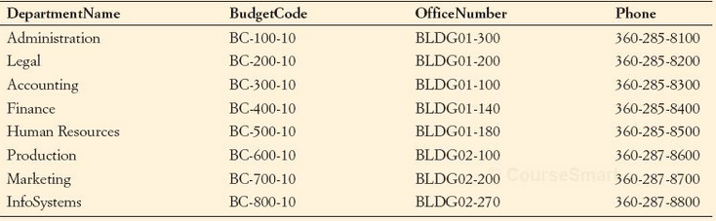

1. Enter into your DEPARTMENT table the data in the DEPARTMENT table shown in the above figure.
2. Create the relationship and referential integrity constraint between DEPARTMENT and EMPLOYEE. Enable enforcing of referential integrity.

**Column Characteristics for the PROJECT Table**

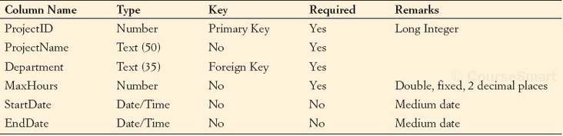

1. The above figure shows the column characteristics for the WPC PROJECT table. Using the column characteristics, create the PROJECT table for the WPC .accdb database.
2. Create the relationship and referential integrity constraint between DEPARTMENT and PROJECT. Enable enforcing of referential integrity.
   1. To add the PROJECT table to the Relationships, right-click on a blank spot in the Relationships window and click **Show Table...**.

**WPC Project Data**

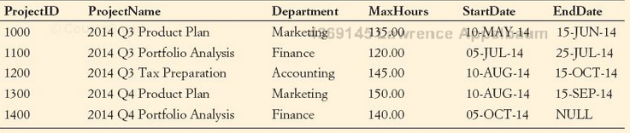

1. Enter into your PROJECT table the data in the PROJECT table shown in the above figure.
   1. To enter a NULL EndDate for ProjectID 1400, simply leave the EndDate field empty.
2. (Skip question G.)

**Column Characteristics for the ASSIGNMENT Table**

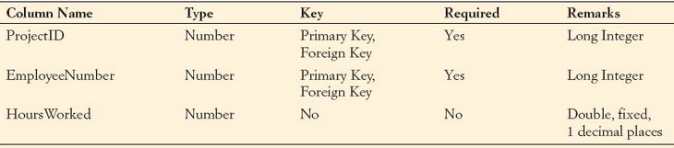

1. The above figure shows the column characteristics for the WPC ASSIGNMENT table. Using the column characteristics, create the ASSIGNMENT table in the WPC.accdb database.
   1. The ProjectID and EmployeeNumber columns together are a composite primary key. Click the gray selection column next to ProjectID, and then ctrl-click (hold the ctrl key and click the left mouse button) the gray selection column next to EmployeeNumber. This should select both columns. Then click the **Primary Key** button on the ribbon.
2. Create the relationship and referential integrity constraint between ASSIGNMENT and PROJECT and between ASSIGNMENT and EMPLOYEE. When creating both relations, enable enforcing of referential integrity.

**WPC ASSIGNMENT Data**

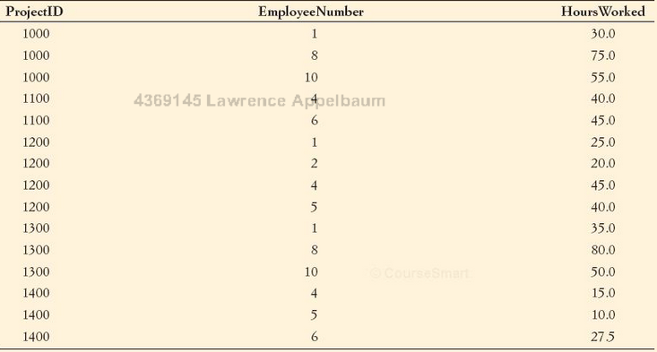

1. Enter into your ASSIGNMENT table the data in the ASSIGNMENT table shown in the above figure.
2. (Skip question K.)
3. For both the DEPARTMENT and EMPLOYEE tables, create a data input form named WPC Department Employee Data Form. This form should show all the employees in each department.
   1. Create a form with a subform. The data for one department should be shown at the top of the form, with the data for all the employees in that department shown in a table at the bottom of the form.
4. Create a stepped report named Wedgewood Pacific Corporation Department Employee Report that presents the data contained in your DEPARTMENT and EMPLOYEE tables in a stepped layout.
   1. You do not need to group employees by department.
   2. Instead of printing out a copy of the report, export the report to a PDF file, and submit it on Blackboard along with your WPC.accdb file.